Legendary Oaks Golf Team
December 2018 Tournament
&
Christmas Party
Saturday, Dec. 22, 2018
Check in: 11:00am
Shotgun: 12:00pm
Party: 5pm--10pm
$50.00 to Play
Included: Green Fee, Food, Wine and Drink, Trophy, Christmas Gift
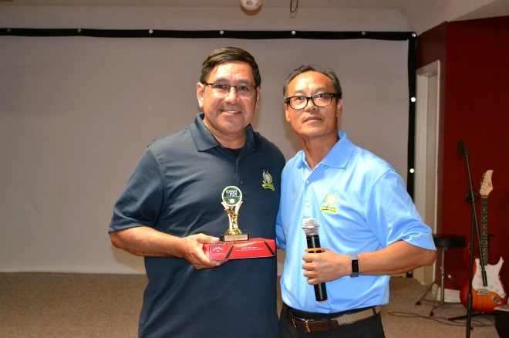

A Flight, B Flight 1st, 2nd, 3rd Trophy and Longest Drive, Closest to The Pin Awards.
Sign Up, Call 979-826-4001, 832-283-8606 or Email: jamesbluo88@gmail.com
*Sign Up Deadline: Dec. 18, 2018*

Legendary Oaks Golf Course
43279 Urban Road, Hempstead, TX 77445
Tel: 979-826-4001 Fax: 979-826-9504 www.legendaryoaksgc.com

